08/02 WK2 Group Meeting

This meeting is a very brief one after our Friday tutorial.

|  |  |
| --- | --- |
| **Location** | Hanna Neumann Building |
| **Date** | 02/08/2019 |
| **Time** | 15:00 - 15:24 |
| **Attendees** | Derek Tan, Lily Zhang,  Jessica Ying, Andre Olivier |

## Agenda items

1. Things to do for Audit 1
2. Divide the tasks

## 1. Things to do for Audit 1

* GitHub repository
* The overall project vision, goal, purpose or objective
* Milestones for each Project Audit
* Identification of resources, risks, potential costs and who will bear them
* Timeline

## 2. Divide the tasks

* Everyone does research about rendering plants to get a general idea.
* Jessica will make a GitHub repository for this group project
* Derek will write up the overall project vision, goal, purpose or objective
* Lily will write about what the project will achieve and the key stakeholders, what do they do, and how they interact.
* Andre will write about the identification of resources, risks, potential costs and who will bear them and timeline

## 3. Tutor’s suggestion

* Approach Ancker, Jiefei and Martin for technical issues
* A detailed economic study might be useful
* Consider the power consumption of the portable rending plant
* Think in term of numbers. Try to make things quantifiable
* Try to show the iterations of the design from industry feedback
* We do not have to have a physical prototype since our project is design-based. It is perfectly fine to just show things from a laptop.
* To get things started, we can do a requirement analysis and a functional analysis, WBS (work breakdown structure). Use the knowledge that we learnt from the system engineering courses.

## 4. Our very first sketching

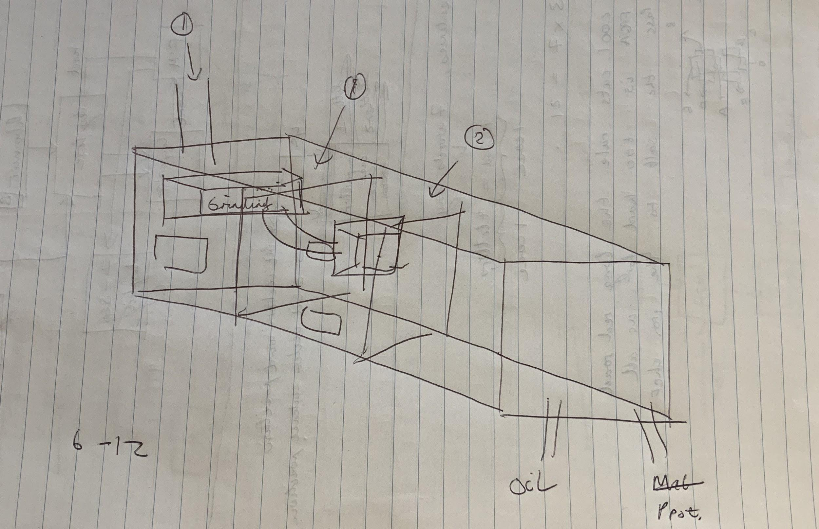

by Andre Olivier

|  |  |  |  |
| --- | --- | --- | --- |
| **Action item** | **Owner** | **Deadline** | **Status** |
| make a GitHub repository | Jessica | 04/08/2019 | Completed  The repository is assessable by everyone |
| Research about rendering plant | Group | 05/08/2019 | Completed |
| The overall project vision, goal, purpose or objective | Derek | 03/08/2019 | Completed |
| Write about what the project will achieve and the key stakeholders, what do they do, and how they interact. | Lily | 05/08/2019 |  |
| Write about the identification of resources, risks, potential costs and who will bear them and timeline | Andre | 05/08/2019 |  |
| Audit 1 presentation preparation | Group | 05/08/2019 | It will be further discussed in our next meeting. |